1. User manual
2. For all kinds of user
3. Register account

Step 1: Click on Sign Up button

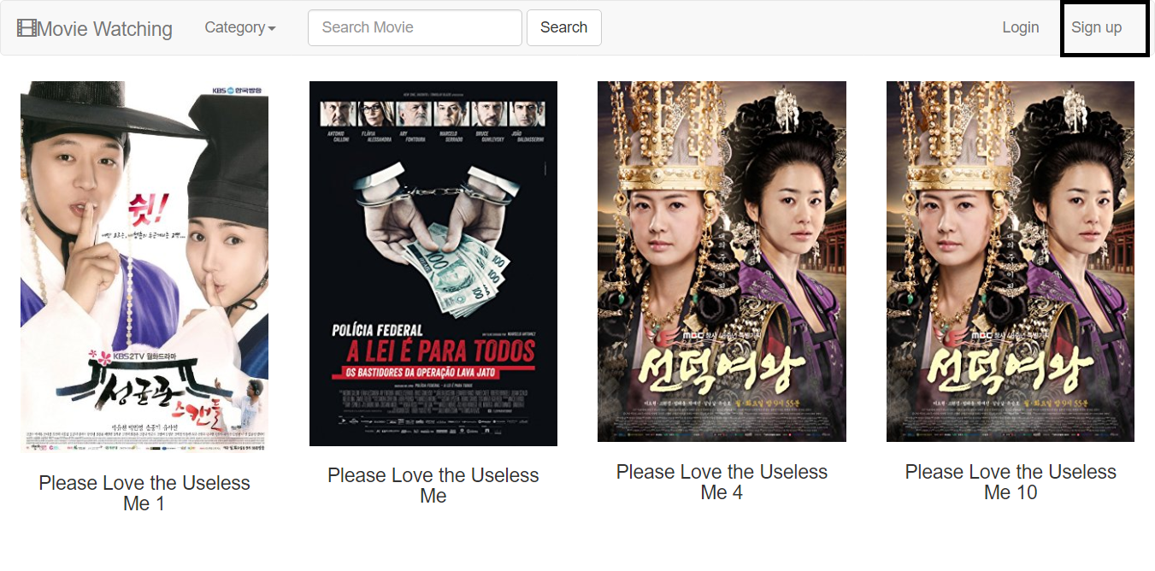

Step 2: Type username, password, email and profile picture link

Make sure that email exists and has not been used to register for other accounts on our website

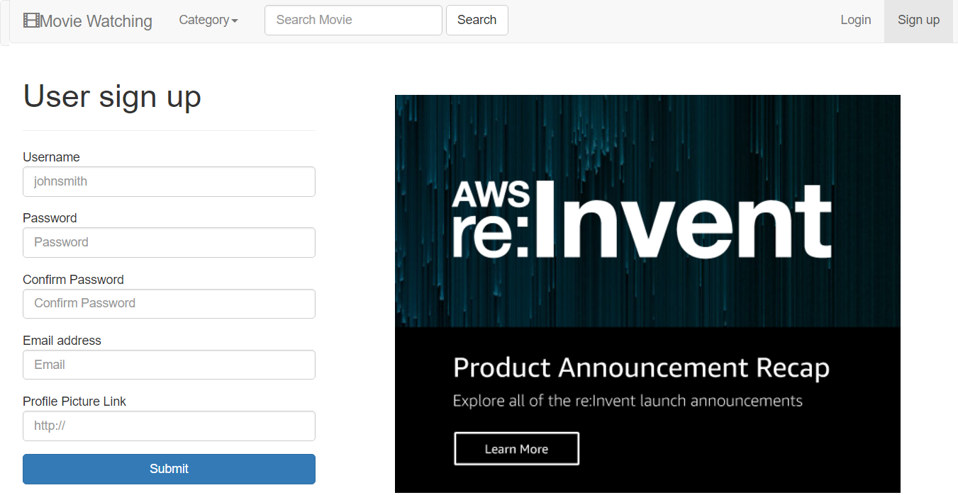

After completing the registration, you will be redirected to Member Homepage

All information will be recorded in our database

1. View Movie List

Step 1: Click on Category to show all category and click your favorite category

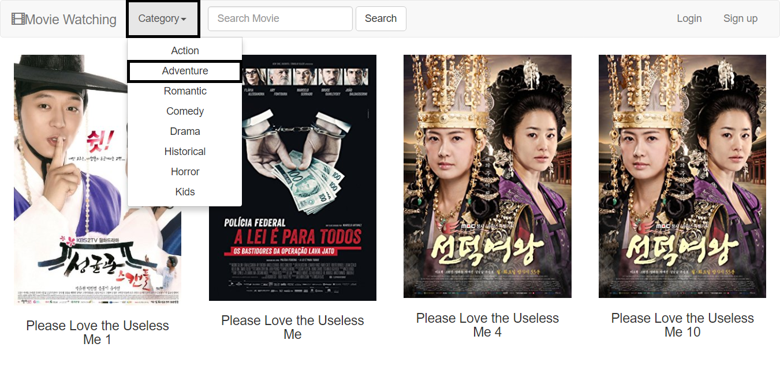

Step 2: View the movie which belongs to the category you choose



1. View Movie Detail

Step 1: Hover the movie image and click the details

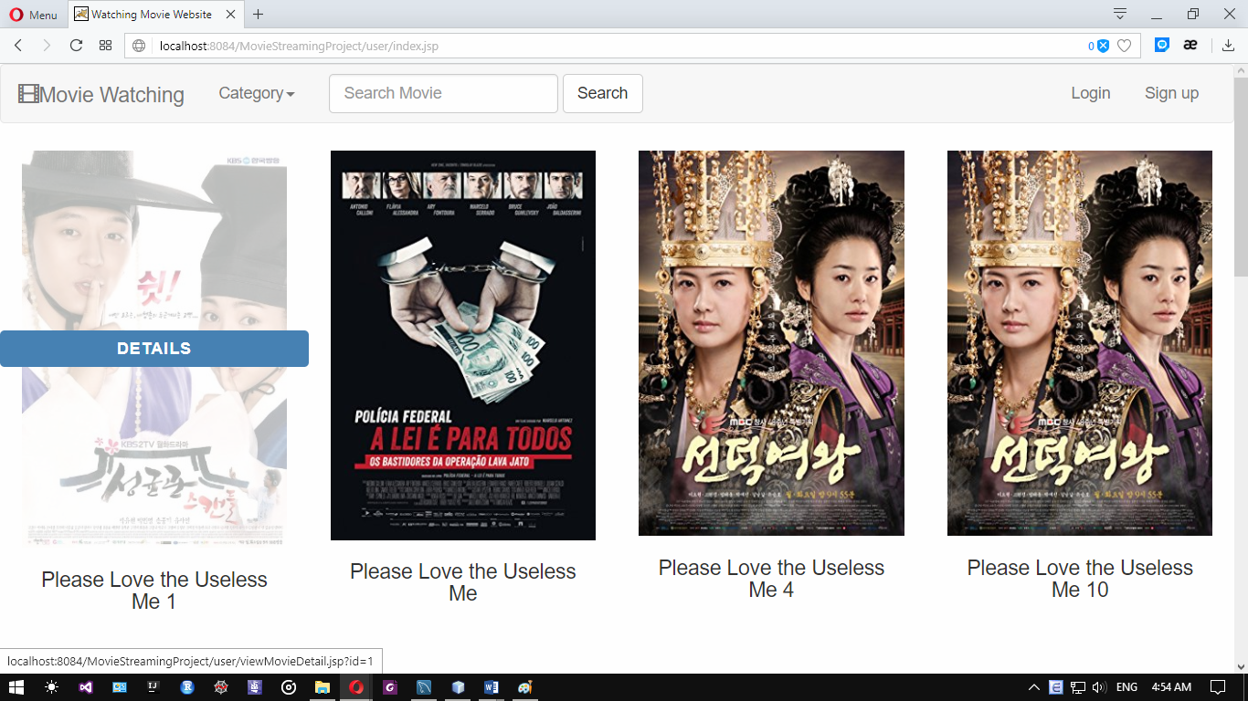

Step 2: View the movie detail you choose

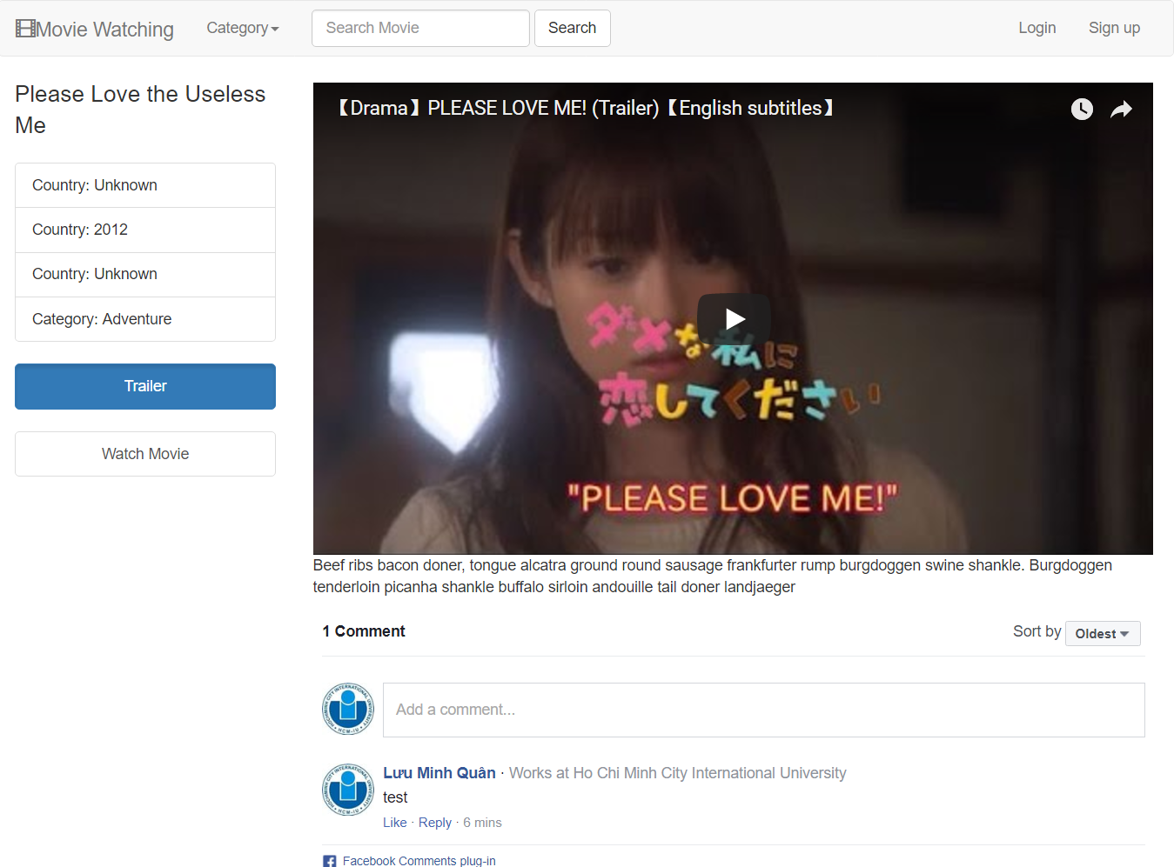

You also watch the movie trailer and comment

1. Search movies

Step 1: Input the keyword on search bar and click search



Step 2: View all movie which relates to your keyword



1. For Member
2. Log in

Step 1: Click on the log in button



Step 2: Type your username and password

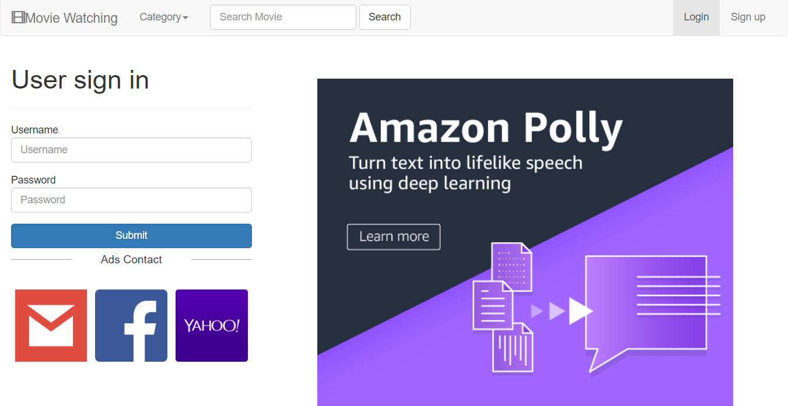

Make sure that your username and password is already existed, otherwise our website will announce

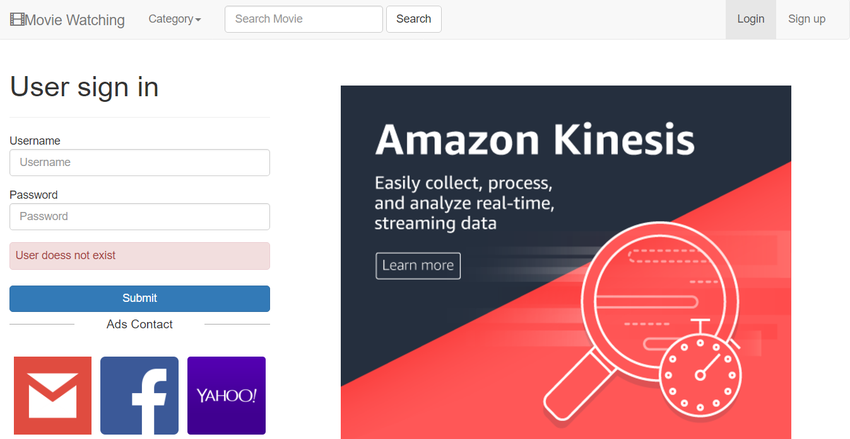

When correct username and password is input, the website will be redirected to Member Homepage

1. Logout

Step 1: When you are in member page, click on Logout

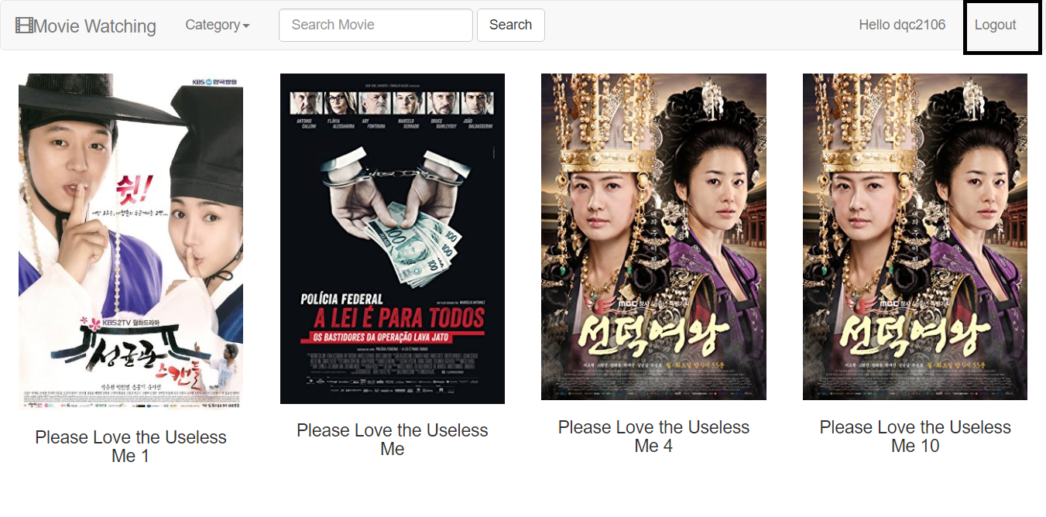

Step 2: Website will alert you to login and be redirected to login page

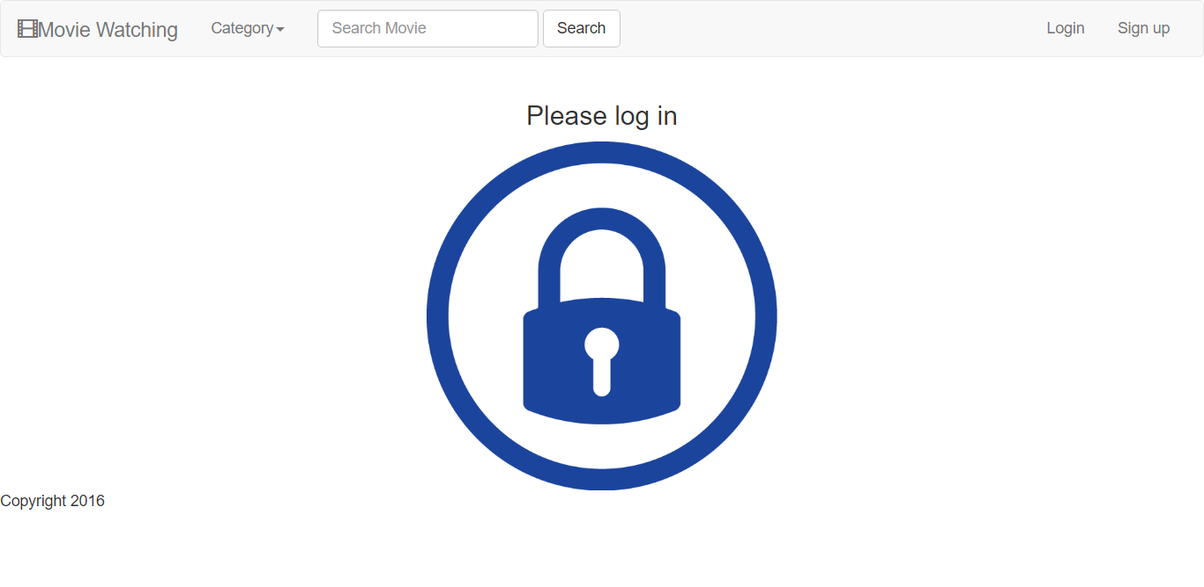



1. View Movie

Step 1: When you are in movie detail page, click on Watch Movie button



Make sure that you have already logged in, otherwise the website will be redirected to login page

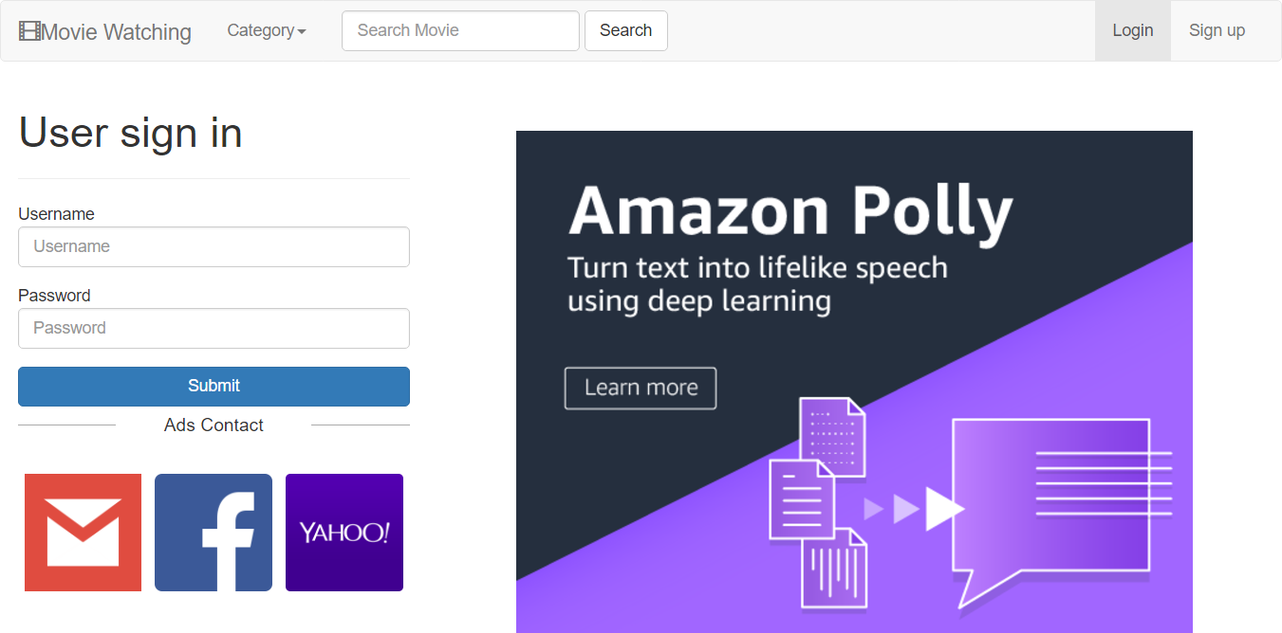

Step 2: When you have already logged in, you can watch movie

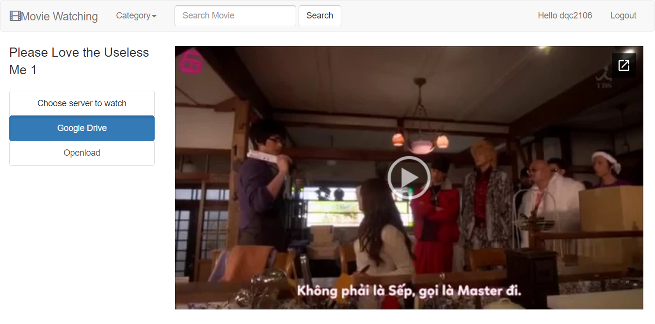

In the view movie page, the default server website chooses is Google Drive, but you can choose another server

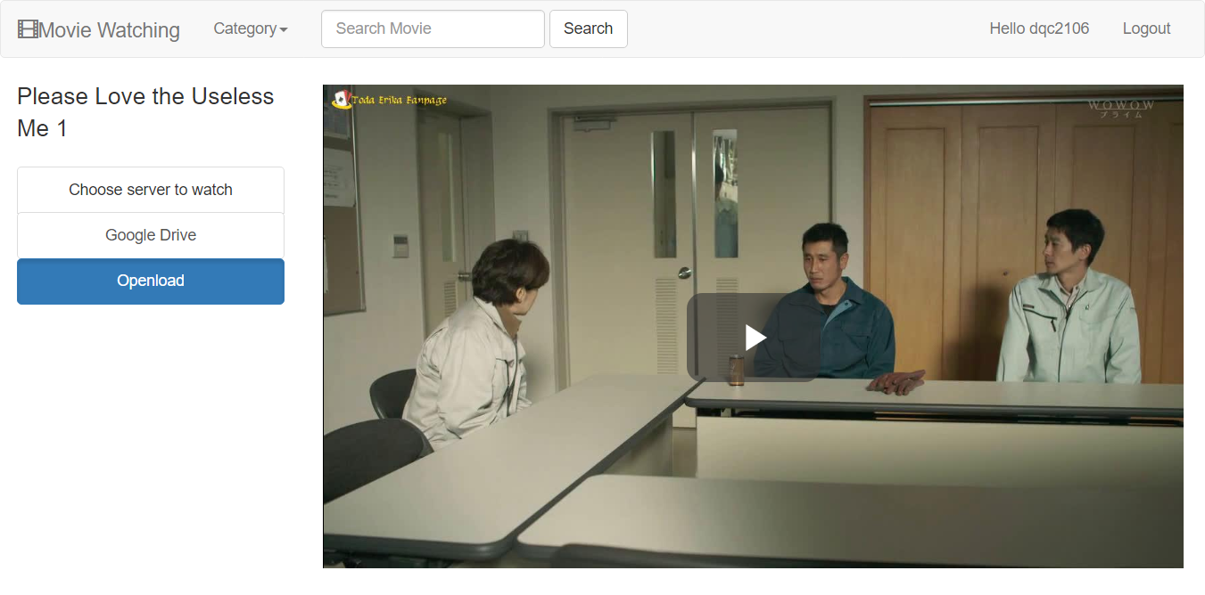

1. Remove favorites

Step 1: Click the view profile as long as you have already logged in

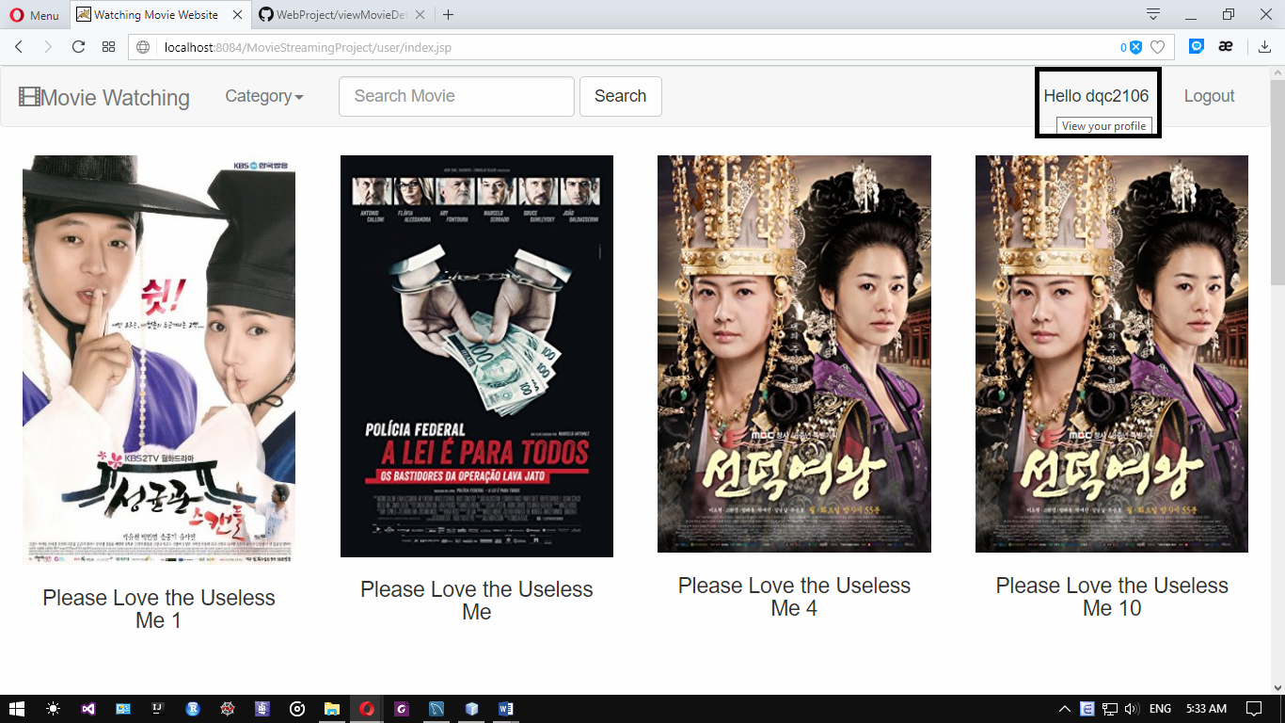

Step 2: Click on trash button of the movie you want to remove

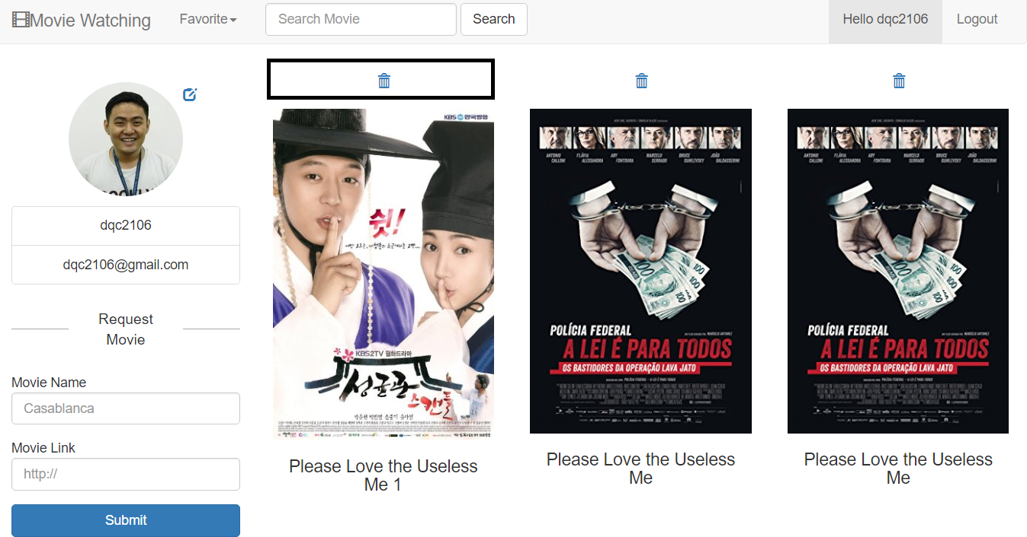

Step 3: Now you can view favorite movie without the movie you remove

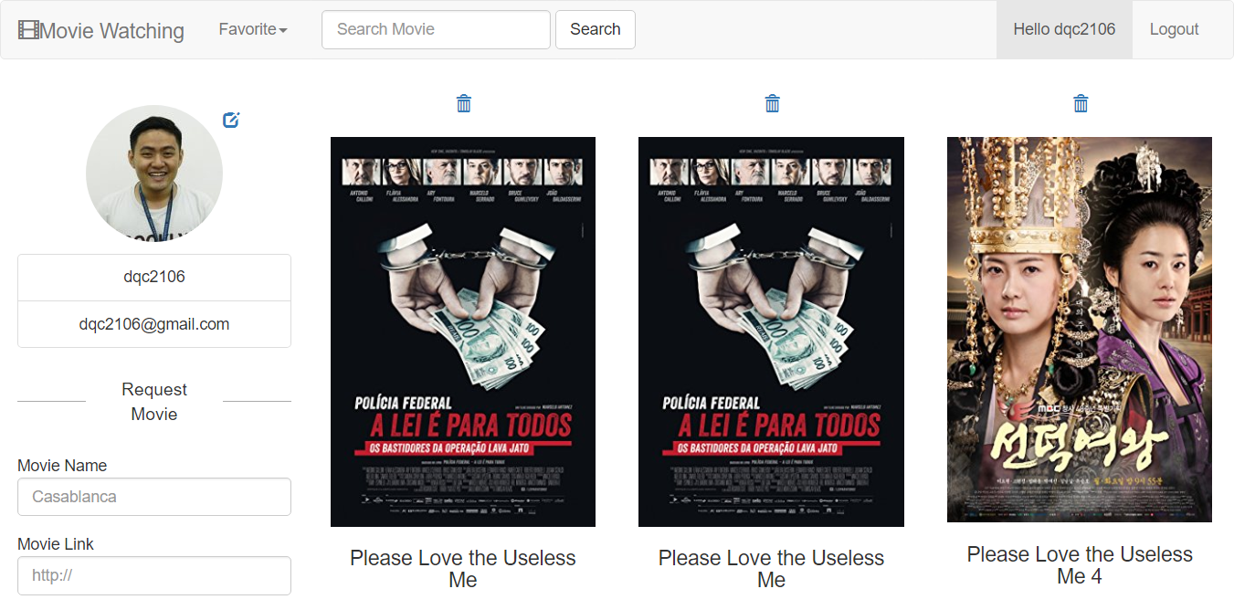

1. View favorites

Step 1: Click the view profile as long as you have already logged in



Step 2: Now you can view all your favorite movie



1. Edit Profile

Step 1: Go to the profile page and click on edit button on right above the profile picture

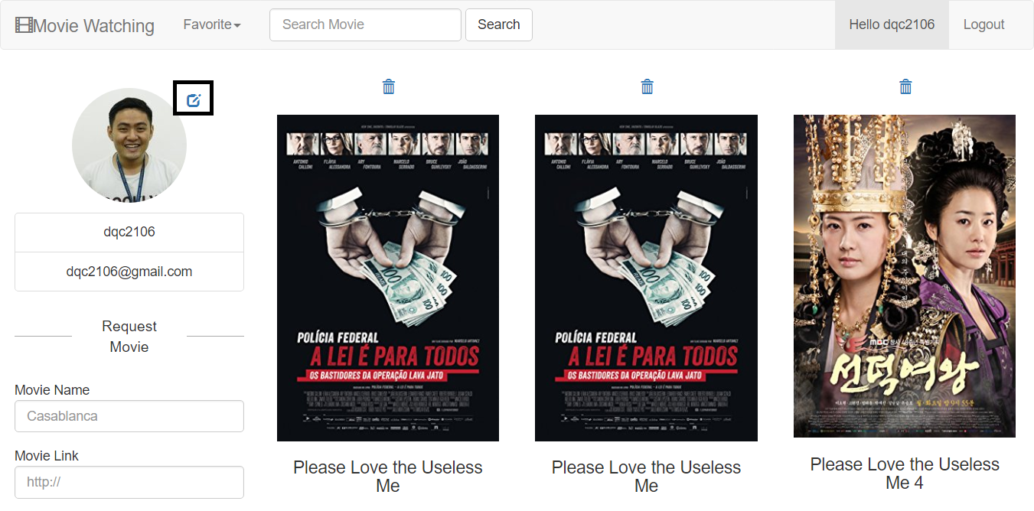

Step 2: Edit old password, email and profile picture link

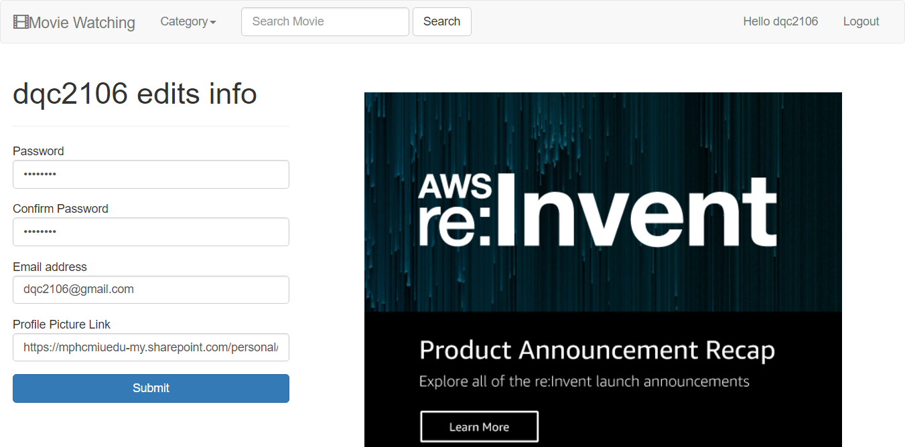

Make sure your new email has not been used to register for other accounts, otherwise

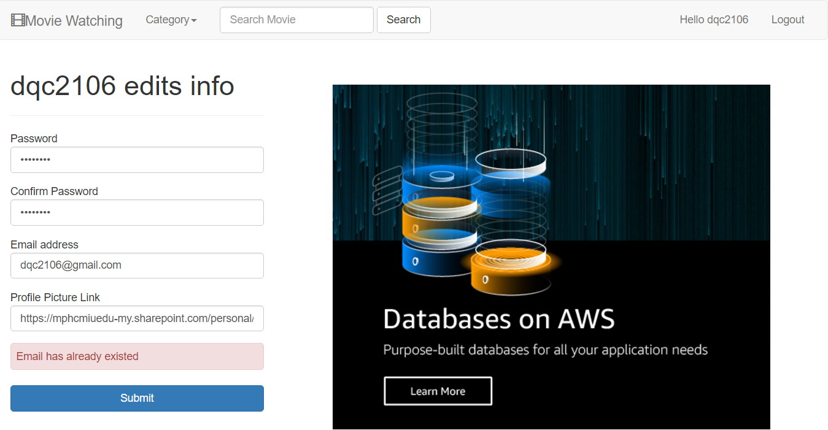

1. For Administrator
2. Remove Account

Step 1: Log in the administration account

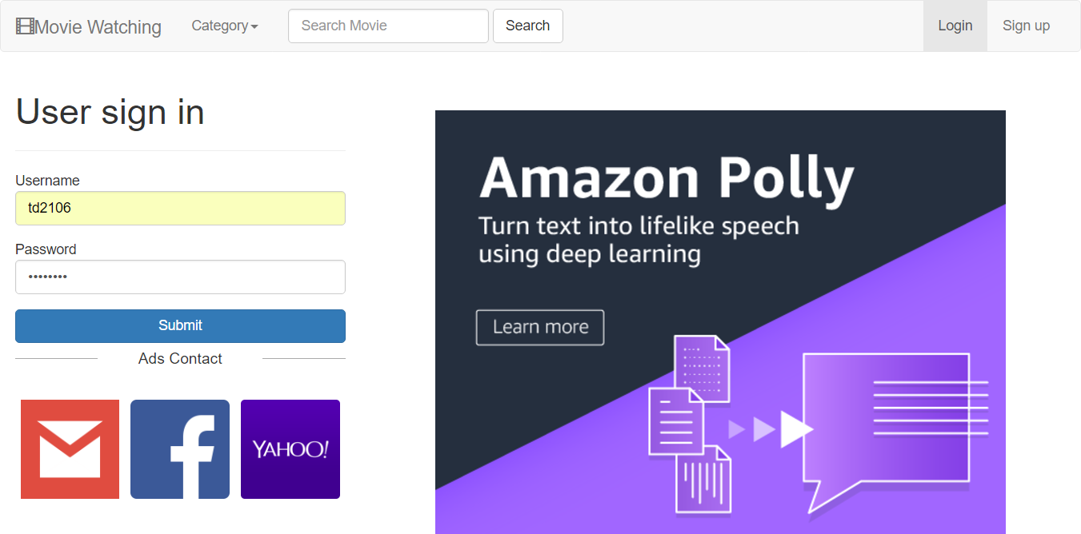

Step 2: Click trash button of movie you want to remove

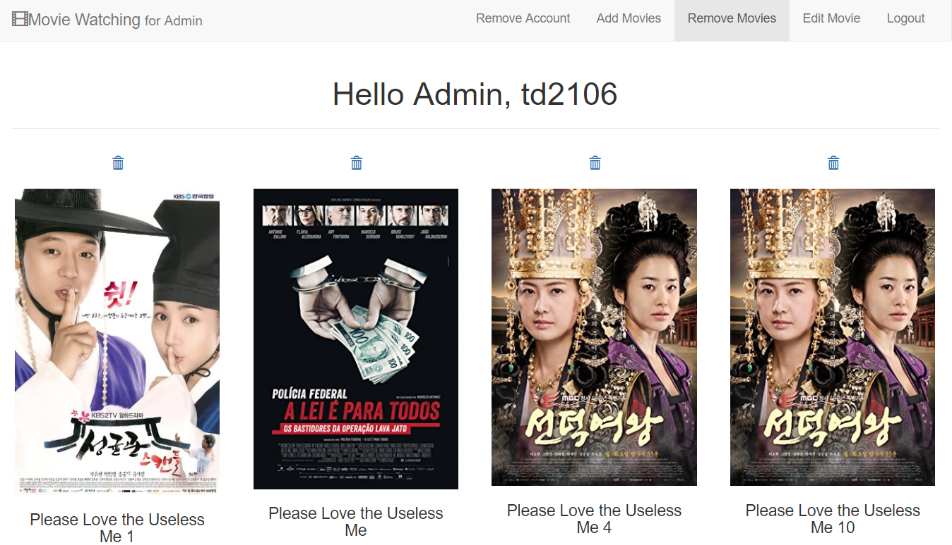

Step 3: After removing, website will be redirected to remove movies page without the movie you remove

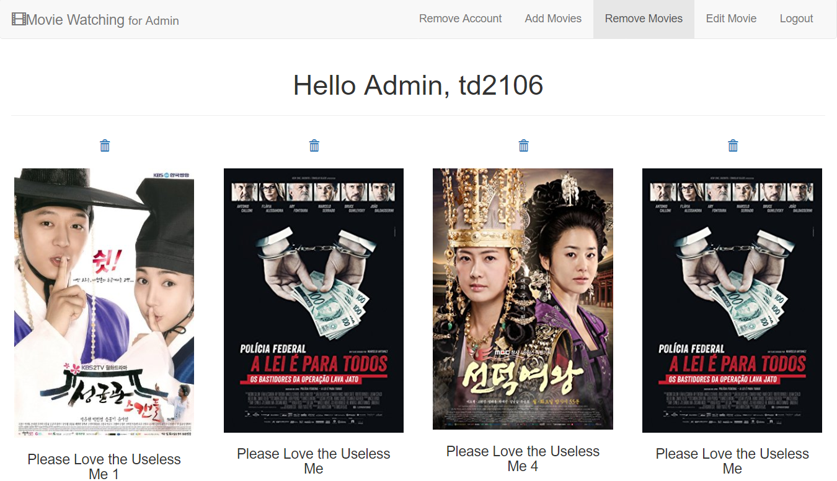

1. Add movies

Step 1: Click on add movies and fill all movie information

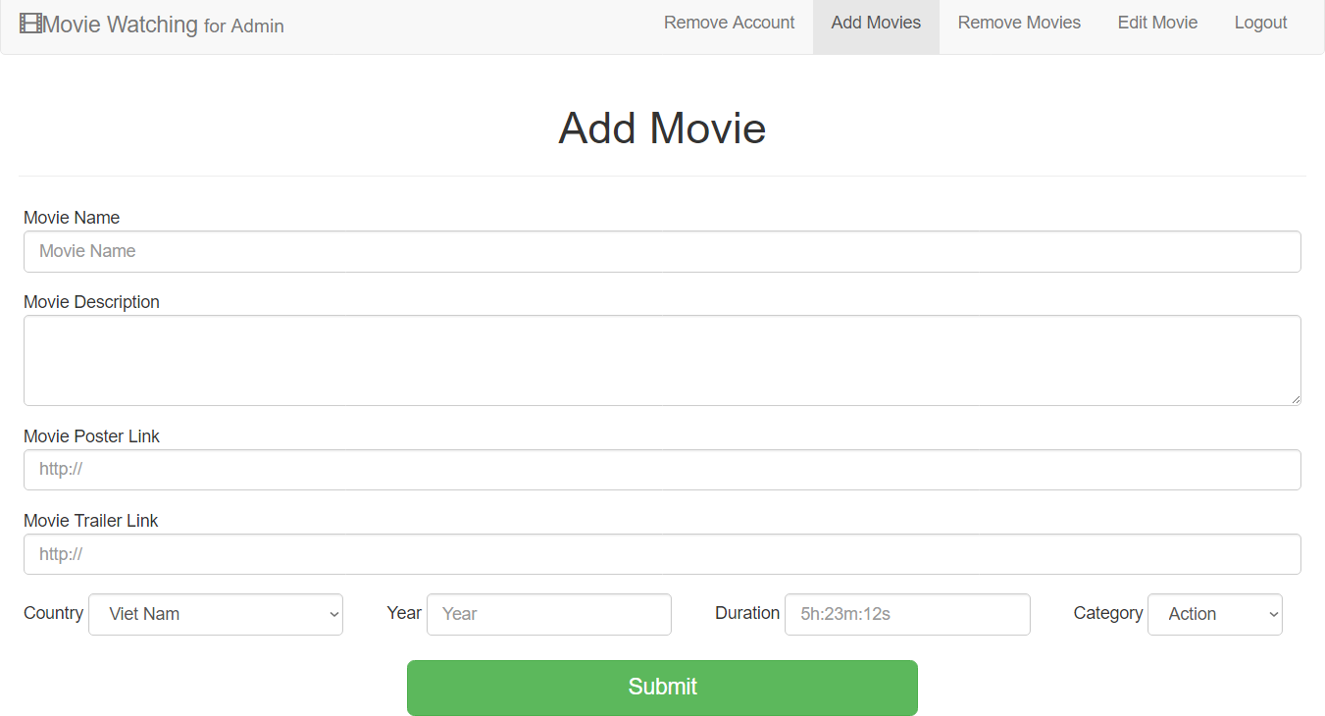

Step 2: Website will be redirected to Administration Panel

Make sure movie name has not been existed in database



1. Remove account

Step 1: Click on Remove Account and choose the account you want to remove

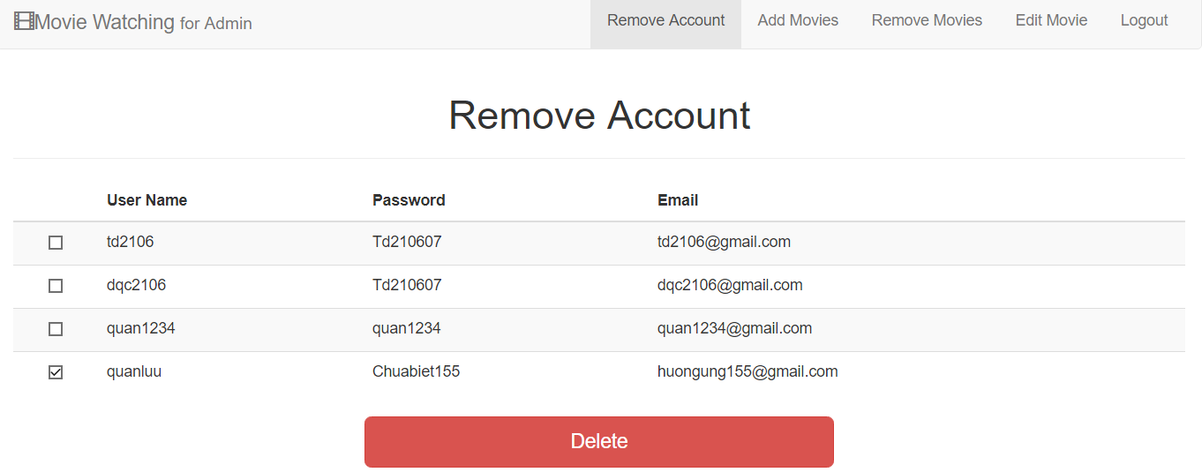

Step 2: After removing

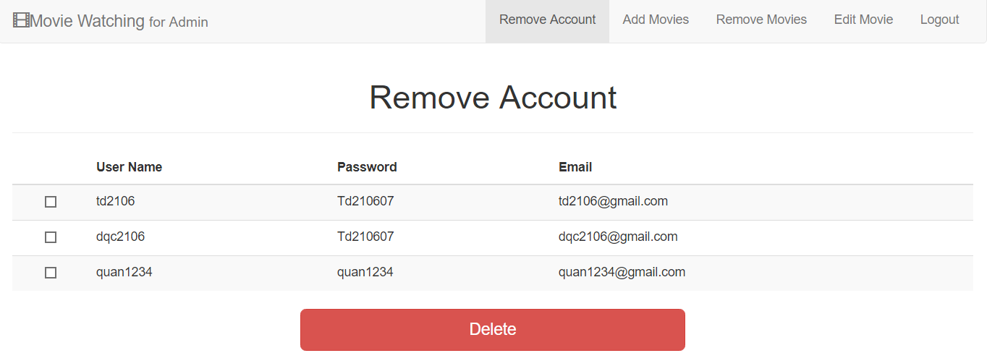

1. Edit movie detail

Step 1: Click on edit movie button and choose the movie you want to edit

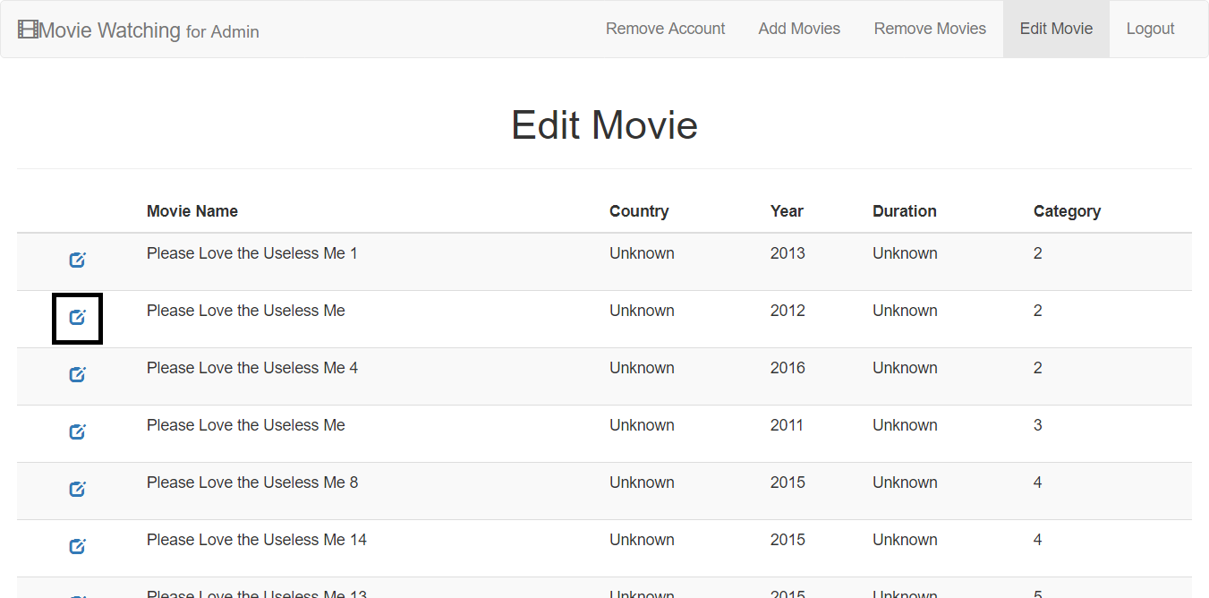

Step 2: Fill movie information and make sure that movie name has not been existed and click edit

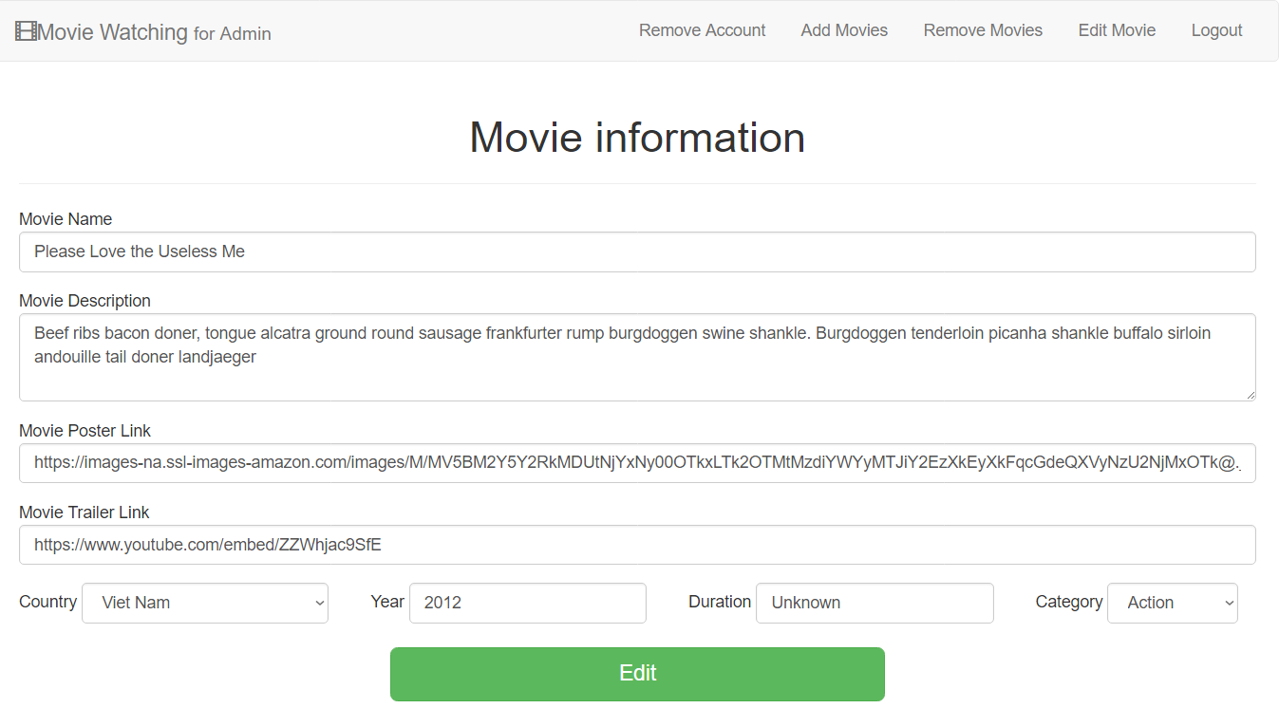

Step 3: After editing, website will be redirected to edit movie page

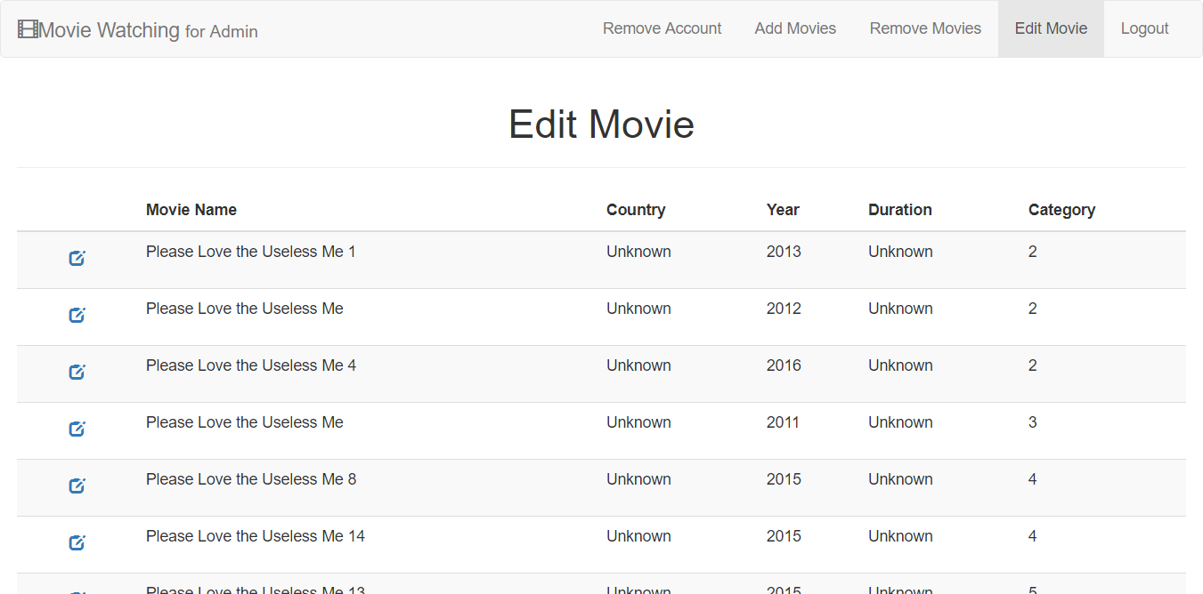

1. Delete movie link

Step 1: Select movie you want to delete link

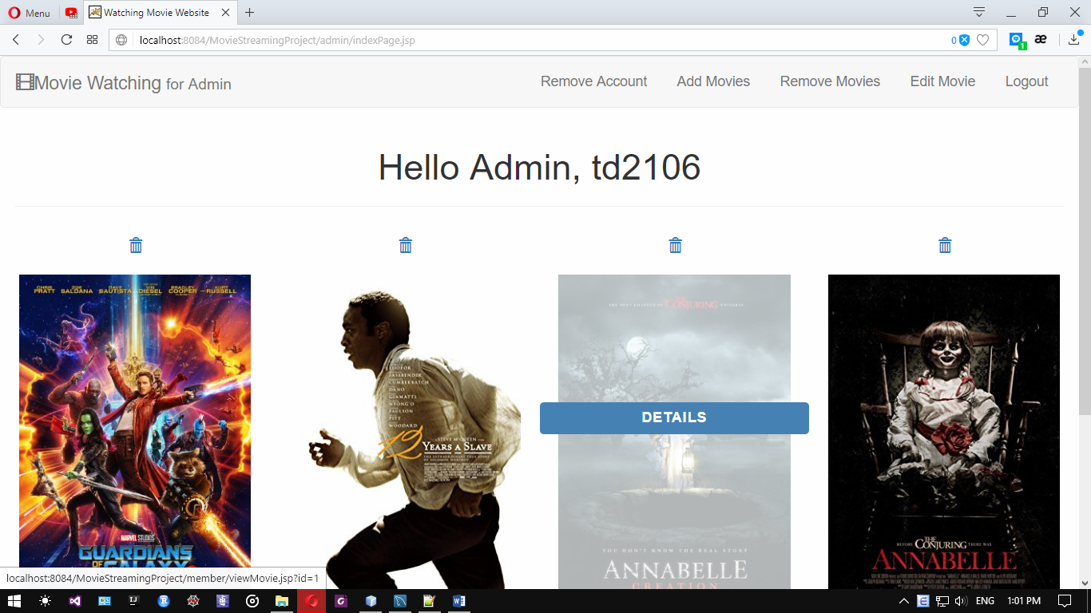

Step 2: Choose link and click delete

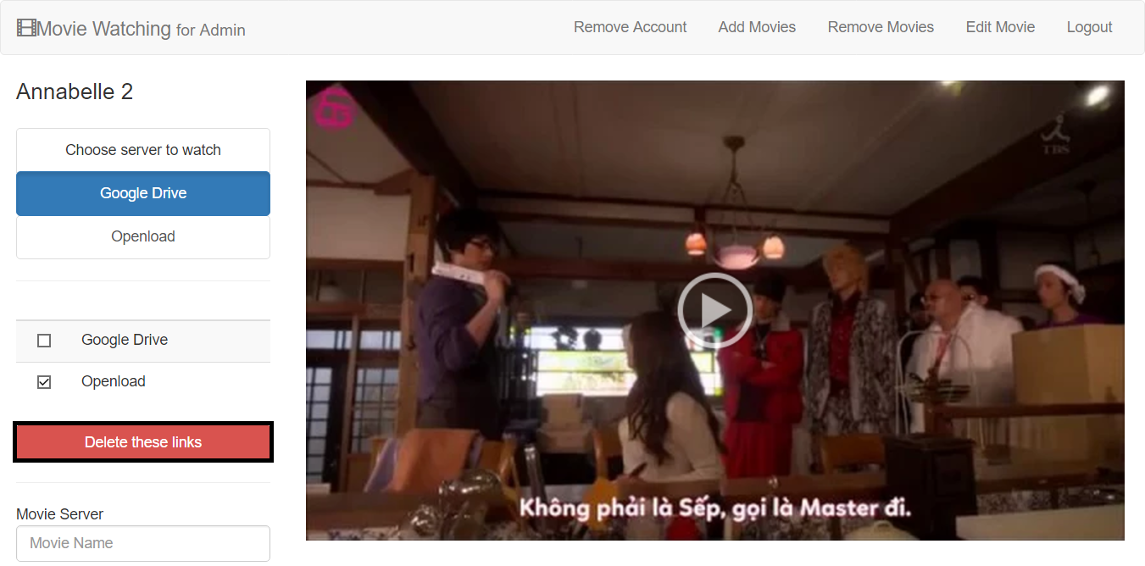

1. Add movie link

Step 1: Select movie you want to delete link



Step 2: Input link name, link and click “Add movie link”

